**Response for Assignment 12.1**

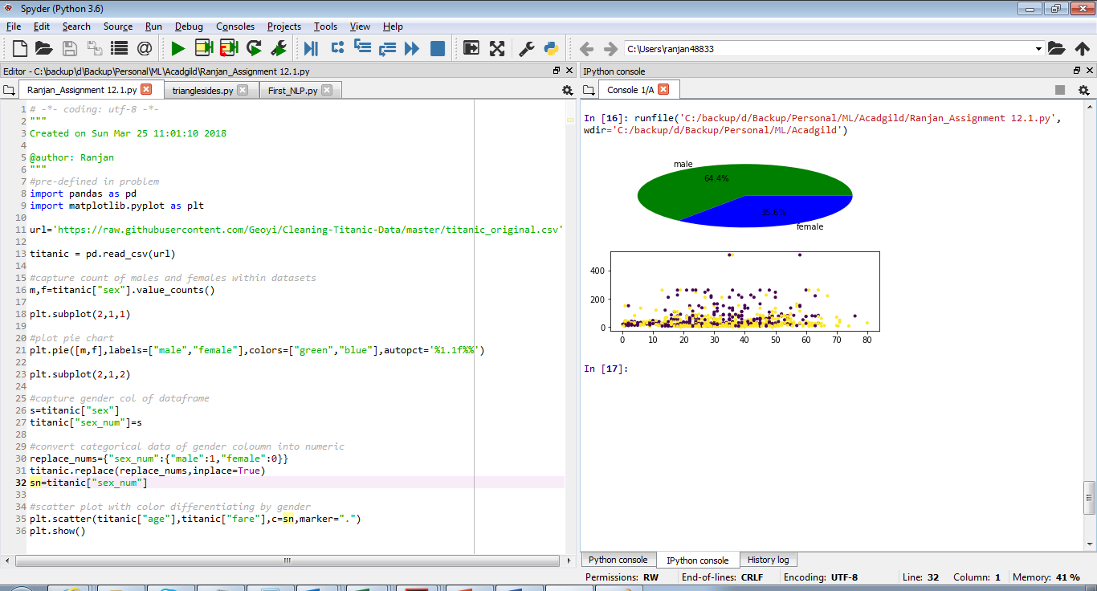

**Below is the source code**

#pre-defined in problem

import pandas as pd

import matplotlib.pyplot as plt

url='https://raw.githubusercontent.com/Geoyi/Cleaning-Titanic-Data/master/titanic_original.csv'

titanic = pd.read_csv(url)

#capture count of males and females within datasets

m,f=titanic["sex"].value_counts()

plt.subplot(2,1,1)

#plot pie chart

plt.pie([m,f],labels=["male","female"],colors=["green","blue"],autopct='%1.1f%%')

plt.subplot(2,1,2)

#capture gender col of dataframe

s=titanic["sex"]

titanic["sex_num"]=s

#convert categorical data of gender coloumn into numeric

replace_nums={"sex_num":{"male":1,"female":0}}

titanic.replace(replace_nums,inplace=True)

sn=titanic["sex_num"]

#scatter plot with color differentiating by gender

plt.scatter(titanic["age"],titanic["fare"],c=sn,marker=".")

plt.show()